LAB EXPERIMENT RECORD
Set 25: Website Traffic Analysis

Department | AIML
Course Code / Course Name | DSA0601 / Data Handling and Visualization
Experiment | Data Visualization using R
Name | G. Ganga Chandrika
Register Number | 1925260144
Date | 20 October 2026
Day | Tuesday

Aim
To analyse website traffic data by visualizing page views over time with a line chart, the top days by click-through rate with a bar chart, user interactions with a stacked area chart, and page views by traffic source with a bar chart.
Dataset: Website Traffic
Date | Page Views | Click-through Rate
2023-01-01 | 1500 | 2.3%
2023-01-02 | 1600 | 2.7%
2023-01-03 | 1400 | 2.0%
2023-01-04 | 1650 | 2.4%
2023-01-05 | 1800 | 2.6%

PROGRAM 1: Line Chart of Page Views Over Time
Create a line chart to visualize the trend in page views over time. Label the axes and title the chart.
# Create dataset
traffic <- data.frame(
Date = as.Date(c("2023-01-01", "2023-01-02", "2023-01-03",
"2023-01-04", "2023-01-05")),
Page_Views = c(1500, 1600, 1400, 1650, 1800)
)
# Create line chart
plot(traffic$Date, traffic$Page_Views,
type = "o",
col = "blue",
pch = 16,
main = "Website Page Views Over Time",
xlab = "Date",
ylab = "Page Views")
grid()
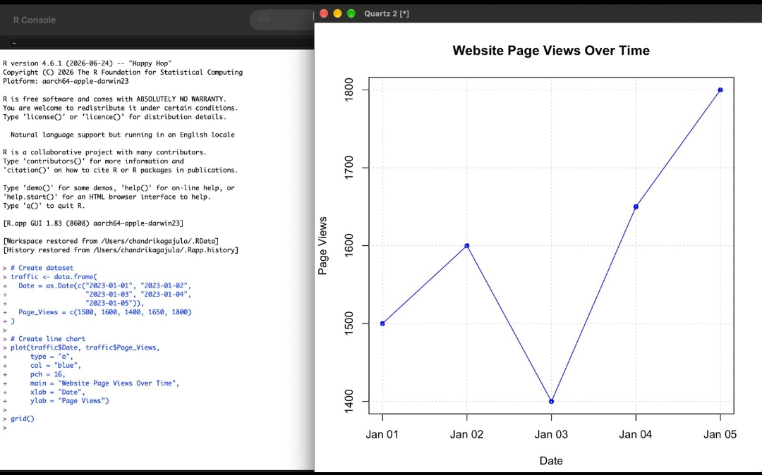
Output 1: Website Page Views Over Time
Observation: Page views rise from 1500 on Jan 01 to 1600 on Jan 02, fall to the lowest value of 1400 on Jan 03, and then increase steadily to the highest value of 1800 on Jan 05.

PROGRAM 2: Bar Chart of Top 3 Days by Click-through Rate
Generate a bar chart to show the top N days (N = 3) with the highest click-through rates. Label the chart elements.
# Create dataset
traffic <- data.frame(
Date = c("2023-01-01", "2023-01-02", "2023-01-03",
"2023-01-04", "2023-01-05"),
CTR = c(2.3, 2.7, 2.0, 2.4, 2.6)
)
# Select top 3 days
top_days <- traffic[order(-traffic$CTR), ][1:3, ]
# Create bar chart
barplot(top_days$CTR,
names.arg = top_days$Date,
col = "orange",
main = "Top 3 Days by Click-through Rate",
xlab = "Date",
ylab = "Click-through Rate (%)",
ylim = c(0, 3))
# Display values on bars
text(x = seq_along(top_days$CTR),
y = top_days$CTR,
labels = paste0(top_days$CTR, "%"),
pos = 3)
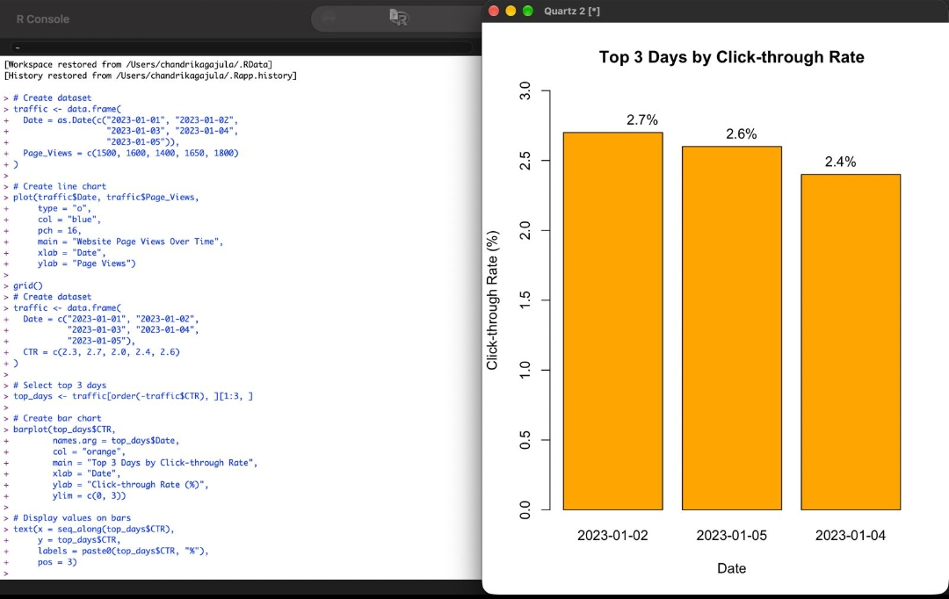
Output 2: Top 3 Days by Click-through Rate
Observation: The three highest click-through rates occurred on 2023-01-02 (2.7%), 2023-01-05 (2.6%) and 2023-01-04 (2.4%).

PROGRAM 3: Stacked Area Chart of User Interactions
Build a stacked area chart to display the distribution of user interactions (likes, shares, comments) on the website.
Date | Likes | Shares | Comments
2023-01-01 | 100 | 40 | 20
2023-01-02 | 120 | 50 | 25
2023-01-03 | 110 | 45 | 22
2023-01-04 | 140 | 60 | 30
2023-01-05 | 160 | 70 | 35

# Create sample dataset
interactions <- data.frame(
Date = as.Date(c("2023-01-01", "2023-01-02", "2023-01-03",
"2023-01-04", "2023-01-05")),
Likes = c(100, 120, 110, 140, 160),
Shares = c(40, 50, 45, 60, 70),
Comments = c(20, 25, 22, 30, 35)
)
# Create stacked area chart
matplot(interactions$Date,
interactions[, c("Likes", "Shares", "Comments")],
type = "n",
main = "Website User Interactions",
xlab = "Date",
ylab = "Number of Interactions")
cols <- c("skyblue", "orange", "lightgreen")
# Draw stacked areas
stacked <- t(apply(interactions[, c("Likes", "Shares", "Comments")],
1, cumsum))
polygon(c(interactions$Date, rev(interactions$Date)),
c(stacked[, 1], rep(0, nrow(stacked))),
col = cols[1], border = NA)
polygon(c(interactions$Date, rev(interactions$Date)),
c(stacked[, 2], rev(stacked[, 1])),
col = cols[2], border = NA)
polygon(c(interactions$Date, rev(interactions$Date)),
c(stacked[, 3], rev(stacked[, 2])),
col = cols[3], border = NA)
legend("topleft",
legend = c("Likes", "Shares", "Comments"),
fill = cols)
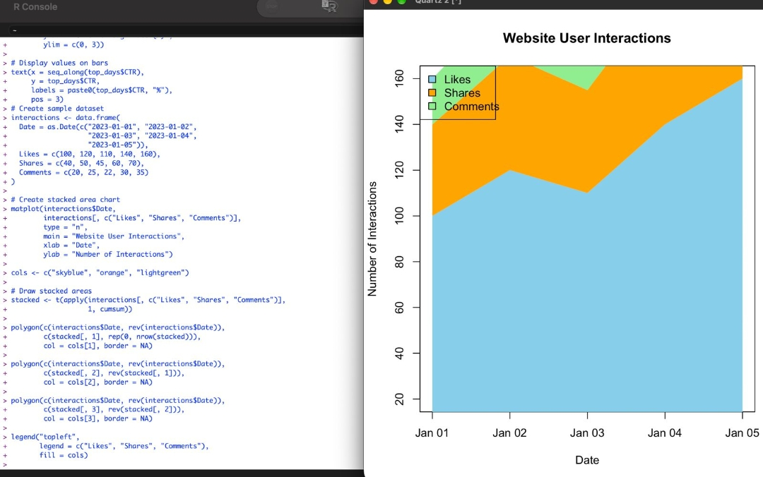
Output 3: Website User Interactions (Stacked Area Chart)
Observation: Likes form the largest portion of the interactions on every day, followed by shares and comments. All three interaction types dip on Jan 03 and reach their highest values on Jan 05.

PROGRAM 4: Page Views by Traffic Source
Create a bar chart displaying the page views by traffic source.
Traffic Source | Page Views
Google | 2500
Direct | 1800
Social Media | 1200
Email | 900
Referral | 700

# Create the dataset
source <- c("Google", "Direct", "Social Media", "Email", "Referral")
page_views <- c(2500, 1800, 1200, 900, 700)
# Create a data frame
traffic <- data.frame(source, page_views)
# Display the dataset
print(traffic)
# Create a bar chart
barplot(traffic$page_views,
names.arg = traffic$source,
col = "skyblue",
main = "Page Views by Traffic Source",
xlab = "Traffic Source",
ylab = "Number of Page Views",
las = 2)
# Display grid lines
grid(nx = NA, ny = NULL)
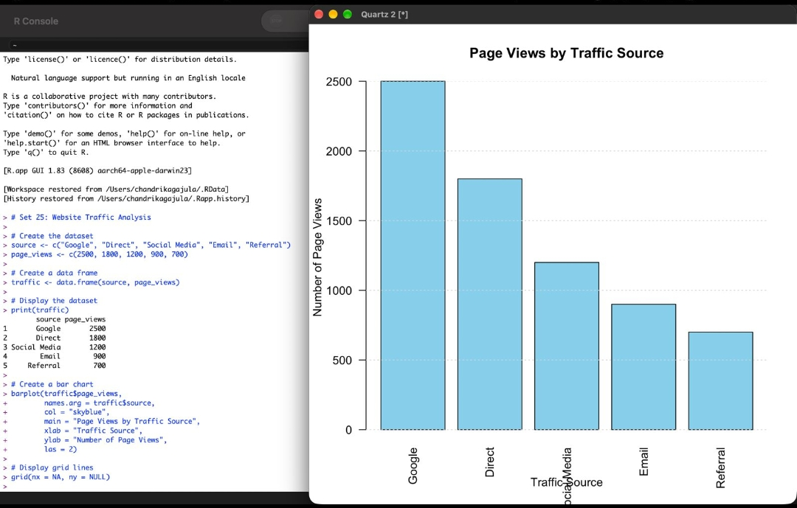
Output 4: Page Views by Traffic Source
Observation: Google brings the most page views (2500), followed by Direct (1800), Social Media (1200), Email (900) and Referral (700).

Procedure
1. Create the website traffic data frame with Date and Page_Views in R.
2. Use plot() with type = "o" to draw the line chart of page views over time, with labelled axes and a title.
3. Create the Date and CTR data, sort it with order(), select the top 3 days and use barplot() and text() to draw the labelled bar chart.
4. Create the Likes, Shares and Comments data, compute cumulative sums with cumsum() and draw each layer with polygon() to build the stacked area chart.
5. Create the traffic source and page views data and use barplot() to display page views by source.
Result
The website traffic data was successfully visualized in R using a line chart of page views, a bar chart of the top 3 days by click-through rate, a stacked area chart of user interactions, and a bar chart of page views by traffic source.
Key R Functions Used
Function | Purpose
data.frame() | Creates the dataset.
as.Date() | Converts text to date values.
plot() | Creates the line chart.
order() | Sorts days by click-through rate.
barplot() | Creates bar charts.
text() | Displays values on the bars.
cumsum() / polygon() | Calculate and draw the stacked areas.
legend() | Adds a legend to the chart.

